

U.S. Army Natick Soldier System Center (NSSC) Lethality Holding Time Calculator Manual
(Formally U.S. Army NSRDEC)

Version 9.06

15 August 2026
Updated 15 August 2026



Index

Introduction to the Holding Time Calculator 3
Statement of Need for the Holding Time Calculator 3
Software and Documentation Repository 4
Accessing the Calculator via the Internet 4
Accessing the Calculator without the Internet 4
Data Entry Limitations in the Calculator 6
General Appearance of the Holding Time Calculator 6
Utilization of the Holding Time Calculator 8
Overview of Data Input Panels in the Calculator 9
In Depth Description of Informational Panel Entries 12
Overview of the View Entry Panels in the Calculator 15
Step-by-step Use of the Calculator 17
Safety of Holding Time Calculations 21
Determination of Holding Time 23
Appendix 1: Definitions 26
Appendix 2: Maximum Flow Rate on Non-MBTS Based Systems 27
Appendix 3: Water Holding Time and Product Holding Time 28
Appendix 4: Measurement of the Holding Tube 30
Appendix 5: Calculating Holding Time with Multiple Pipe Diameters 32
Appendix 6: Location of the Recorder / Controller in HTST Systems 35
Appendix 7: Holding Tube Pressure Requirements when utilizing Indirect
Heating with a Normal Operating Temperature of ≥89˚C 38
Technical Points of Contact for the Holding Time Calculator 39
References 39

Introduction to the Holding Time Calculator
The U.S. Army Natick Soldier System Center (NSSC) Lethality Holding Time Calculator Manual
(Formally U.S. Army NSRDEC) is a U.S. Food and Drug Administration (FDA) validated and Department of Defense (DOD) Food Risk Evaluation Committee (FREC) approved dairy and fluid egg holding time calculator software tool that may be used to determine if holding time and temperature combinations used to pasteurize fluid dairy products, such as milk, cream, ice cream mix, eggnog, or pasteurized fluid egg products meet the minimum requirements set forth in MIL-STD-3006 (see References 1, 2, and 3). Instead of using the rigid time and temperature combinations in the Pasteurized Milk Ordinance (PMO) for dairy products (see Reference 4), and the Code of Federal Regulations (CFR) 9 CFR 590.570 (see Reference 5) with regards to pasteurized fluid egg products, the holding time calculator utilizes finely tuned thermal death curves to assess any time and temperature combination.
See the “Note” on page 22 under “Safety of Holding Time Calculations” Pasteurization of Fluid Egg Products with regards to pasteurized fluid egg products.

The calculator may be used to determine any of the following:
- Actual product holding time.
- Minimum required cut-out temperature.
- Maximum allowed flow rate.
- Minimum required length of the holding tube.
- Optimum distance of the recorder / controller from the flow diversion valve.

Statement of Need for the Holding Time Calculator
The holding time calculator is required for three primary reasons:
- To verify processor’s measured and / or calculated holding times.
- To calculate holding time when it cannot be otherwise measured.
- To determine if time and temperature combinations meet the definition of pasteurization.

Note: Even when holding time is measured by the processor, the holding time calculator is an available tool to determine if the definition of pasteurization was met.

There are two cases where holding time cannot be measured by salt injection or other physical means:
- HHST (Higher-Heat Shorter-Time) systems located inside and outside the United States. By definition, the holding time of HHST systems is so short that it cannot be measured. In that case, the PMO provides a calculation procedure. The holding time calculator utilizes the calculation procedure in the PMO for all HHST systems.
- HTST (High-Temperature Short-Time) and LTLT (Lower-Temperature Longer-Time) systems located outside the United States. The design and operation of these HTST and LTLT systems rarely allows empirical measurement of the holding time. The holding time calculator provides an alternate method, like the HHST procedure in the PMO, for calculating the holding time in HTST and LTLT systems.

Software and Documentation Repository
The NSSC Lethality Calculator (formally referred to as NSRDEC Calculator) is a software tool that calculates product holding time and compares it against the thermal death curve for the specified product to determine whether the definition of pasteurization, ultra-pasteurization, or commercial sterility is met. The calculator can be accessed via the following methods.

Accessing the Calculator via the Internet

Type the following URL into a Google Chrome, Microsoft Edge or Firefox browser.

https://vsilves.github.io/Calculator/
Note: The address is case sensitive, so capital “C” in Calculator is required!

Open via a mobile phone using the QR code below or the URL above.



Accessing the Calculator without the Internet

You can save the calculator on your computer for local (off-line) use. This is important if you are unable to access the internet to perform verification calculations during an audit. To have the ability to utilize the Calculator on your device without being connected to the internet for “off-line use”, follow the steps below:

See also this video showing procedures for Chrome and Edge:
https://www.youtube.com/watch?v=Cvfe9ZH-slM

Google Chrome - Procedures
- Open the URL: https://vsilves.github.io/Calculator/
- Click the three black vertical dots in the upper right corner. 
- Hover over ‘Save and share’ or “Cast, save, and share”
- Click on “Save page as” or “Install page as app”.
- The File name will show as ‘Holding Time Calculation.html’, however you can name it whatever you want. You need to determine where you want to save the file (e.g., Desktop).
- Click on “Save as type:” and select “Webpage, HTML Only (*.html:*htm)”.
Note: If you leave it at the default setting the page will NOT open for offline use.
- Click Save.

Microsoft Edge - Procedures
- Open the URL: http://vsilves.freeshell.org/calc.html
- Click the three black horizontal dots in the upper right corner. 
- Hover over ‘More tools”
- Click on “Save page as”.
- The File name will show as ‘Holding Time Calculation.html’, however you can name it whatever you want. You need to determine where you want to save the file (e.g., Desktop).
- Click on “Save as type:” and select “Webpage, HTML Only (*.html:*htm)”.
Note: If you leave it at the default setting the page will NOT open for offline use.
- Click Save.

Firefox - Procedures
- Open the URL: http://vsilves.freeshell.org/calc.html
- Click the three black horizontal line in the upper right corner. 
- Click on ‘Save page as’
- The File name will show as ‘Holding Time Calculation.html’, however you can name it whatever you want. You need to determine where you want to save the file (e.g., Desktop).
- Click Save.
- Click on “Save as type:” and select “Webpage, HTML Only (*.html:*htm)”.
Note: If you leave it at the default setting the page will NOT open for offline use.
- Click Save.

Data Entry Limitations in the Calculator

The holding time calculator accepts three forms of data input.
- Drop-down lists.
- Free-form numerical input fields.
- Action buttons.

Only one item can be selected at a time in drop-down lists.

Numerical entry fields allow the typing of any character, however, only numbers and one decimal point (“.”) are interpreted correctly (e.g., 72.15 or 0.5).

Note: Do not enter any thousand separators (e.g., enter 25000 instead of 25,000) or any other extraneous characters.

Finally, actions buttons (labeled “Max” or “Min”) instantaneously change some of the input values, therefore, input values may need to be reset afterwards to consider alternate scenarios.

General Appearance of the Holding Time Calculator
As an example, using Microsoft Edge, the default view of the holding time calculator is as shown below. The appearance may vary slightly depending on your browser.

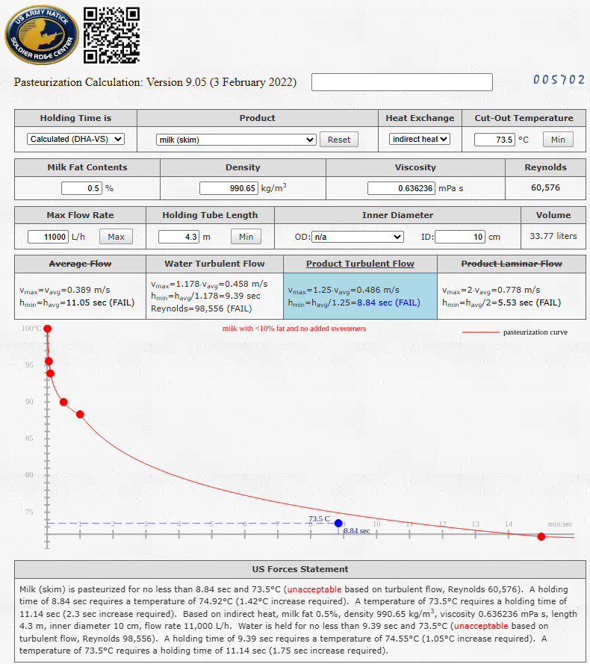
Informational Panels
Data Input Panels
Note: Depending on the product selected, some panels may hide. For example, when a fluid egg product is selected, the panel for the milk fat, density, viscosity and Reynolds is unnecessary and, therefore, automatically hidden as shown below.

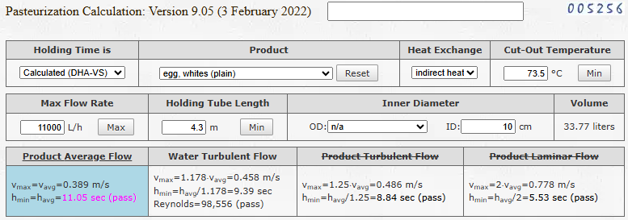

When holding time is measured instead of calculated [select “Measured (FDA-PMO)” in the “Holding Time is” drop-down list], even less information is necessary or shown in this case. The calculator is still useful to check measured holding times and temperatures against the thermal death curve for the selected product, as shown below.
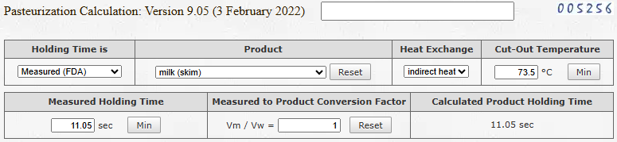

Utilization of the Holding Time Calculator
Before using the holding time calculator, you should receive specialized dairy training from U.S. Army Europe Public Health Command Europe (PHCE) Veterinary Services Division (VSD) dairy subject matter experts, and if possible, attend the basic Food and Drug Administration (FDA) PMO course.

The holding time calculator is broken down into three data input panels (top) and three informational panels (bottom), as shown in the previous pages. Panels contain multiple entries as follows.

Data Input Panels:  - Holding Time is.  - Product.  - Heat Exchange.  - Cut-Out Temperature.  - Milk Fat Contents (only for dairy).  - Density (only for dairy).  - Viscosity (only for dairy).  - Reynolds (only for dairy).  - Max Flow Rate.  - Holding Tube Length.  - Inner Diameter.  - Volume. | Informational Panels:  - Average Flow.  - Water Turbulent Flow.  - Product Turbulent Flow.  - Product Laminar Flow.  - Process Lethality (UP only).  - Target Lethality (UP only).  - Thermal Death Curve (graph).  - US Forces Statement.

Note: Data in the “Data Input Panels” can be entered top-to-bottom and left-to-right or out-of-order. The “Informational Panels” are updated in real time as soon as any input data is added or changed.

View Drop Down Panels:  - Show Sliders  - Show TS Assessment  - Show Boiling Pressure  - Show Known Volume  - Show Recorder Assessment  - Hide Rheological Assessment  - Show Lethality Assessment  - Graph  - Hide Statement | 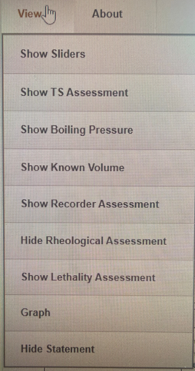
Note: Data in the “View Panels” are addressed in detail on page 15.

Overview of Data Input Panels in the Calculator
This is a brief overview of the input data fields and their function. Hovering the mouse pointer over fields in the calculator also provides a brief synopsis of their function.

ENTRY | OPTIONS | DESCRIPTION
Holding  Time  is | *Calculated (DHA-VS)  Calculated (NSRDEC)  Calculated (FDA)  Measured (FDA)  *In the DHA-VS mode the calculations are “more” conservative and goes even further, if holding time is 1 sec or less it forces Laminar regardless of Reynolds. NSRDEC does not do that. Use DHA-VS (only approved one), if it passes, good. If they fail (close to curve) use NSRDEC and decide if they pass. Honor NSRDEC with an explanation of why. | Default is set to “Calculated (DHA-VS)”, which is the Official Approved Version. Assumes turbulent flow only on HTST (hold > 1 sec) when Reynolds > 10,000 with a fixed flow factor of 1.25.  The NSSC (NSRDEC) version assumes turbulent flow whenever Reynolds > 10,000 and uses a variable flow factor.  The calculated FDA version always assumes laminar flow (with a 2.0 flow factor).  The measured FDA version accepts known empirical measurements instead of calculating holding time. Assumes worst case scenario of laminar flow for both water and product (Utilized in Appendix 5).
Product  *See the “Note” under “Safety of Holding Time Calculations” Pasteurization of Fluid Egg Products with regards to pasteurized fluid egg products. (page 22). | milk (skim) - 0.5%  milk (low fat) - 1%  milk (reduced fat) - 2%  milk (whole) - 3.25%  milk (10% fat) - 10%  milk (18% TS) - 3.25%  milk (w/ added sweeteners) - 3.25%  cream (half and half) - 18%  cream (medium) - 25%  cream (manufacturers) - 40%  mix (ice cream) - 15%  mix (eggnog) - 6%  cream (for butter) - 40%  cream (for plastic) - 40% (60-80%)  UP (dairy products) - 0%  UP (all other products) - 0%  *egg, whites, plain (SE Negative Only)  egg, whole, plain  egg, whole, blends (<2% added TS)  egg, whole, sugared (2-12% added TS)  egg, yolk, plain  egg, whole, blends (2-12% added TS)  egg, whole, salted (≧2% added TS)  egg, yolk, sugared (≧2% added TS)  egg, yolk, salted (2-12% added TS)  *egg, whites, plain, pH 7.8 (5.7-log)  *egg, whites, plain, pH 8.2 (5.7-log)  *egg, whites, plain, pH 8.8 (5.7-log)  *egg, whites, plain, pH 9.3 (5.7-log)  “Reset” button | Selects the type of raw product (milk, cream, mix or egg) being pasteurized or ultra-pasteurized (UP), which in turn determines which thermal curves are utilized:  - milk < 10% fat and no added sweeteners.  - milk ≧ 10% fat, or ≧ 18% TS (total solids), or any added sweeteners.  - eggnog and ice cream mix.  - UP products (dairy and non-dairy).  - egg.  Selecting a product also sets a pre-defined fat % (see below), as indicated, however the fat % can be adjusted accordingly.  Note: For dairy products, this is the milk fat % of the raw product following any standardization or addition of ingredients that will go through the holding tube, not the milk fat % of the product coming into the balance tank.  Pressing the “Reset” button clears all the input fields. Useful to avoid leaving incorrect values when assessing new / additional pasteurizers.

Heat Exchange | *indirect heat  direct heat  *When utilizing egg products, always utilize “indirect heat” for all egg calculations! | Select “indirect heat” for both heat exchange plates and tubular heat exchangers, since the heating medium does not contact the raw or pasteurized product (product-to-steel-to-product).  HHST pasteurizers often need to heat product to, or above, the boiling point and require either steam infusion or steam injection prior to the beginning of the holding tube. In this case select “direct heat”. A 12% steam expansion factor will be added to the calculations (shorten holding time).
Cut-Out Temperature | temperature in ºC  “Min” button | Enter the lowest cut-out temperature used in the system in degrees Celsius. The cut-in or normal operating temperatures do not cover the worst-case scenario and should not be entered.  Pressing the “Min” button will determine, and enter, the minimum temperature required to meet the current thermal curve, given the length, diameter and flow rate.  Normally cut-out < cut-in < normal operating temperature. Changing cut-out will also recalculate density and viscosity (see below).
Milk Fat Contents  (dairy only) | fat % | Enter the highest fat content of the product processed in the pasteurizer (worst case scenario for that product type).  See the Note under the “Product” Entry section on the previous page.  Note: If the same pasteurizer is used to pasteurize different products at different temperatures and / or flow rates, as well as different milk fat % (< 10% and ≧10%) and Total Solids (< 18% and ≧18%), then a separate calculation is required to be completed, even though it is the same pasteurization system.  Changing the product type will reset the fat % so you may need to re-enter fat %, if it is different from the default value for each product. Also, changing fat % re-calculates density and viscosity (see below).
Density  (dairy only) | density in kg/m³ | This value is automatically calculated based on cut-out temperature and fat %. Do not change this value unless raw product density is measured at the cut-out temperature.

Viscosity  (dairy only) | viscosity in mPa s | This value is automatically calculated, in milliPascals second, also known as centipoise (cP), based on the cut-out temperature and fat%. Do not change this value unless raw product viscosity is measured at the cut-out temperature.
Reynolds  (dairy only) | unit-less Reynolds number | This value is calculated automatically and cannot be altered.
Max Flow Rate | flow rate in L/h  “Max” button | Enter the maximum flow rate possible in the holding tube in liters/hour.  Note: Do not use any commas in numbers (e.g., enter 11000, not 11,000).  Pressing the “Max” button will determine, and enter, the maximum flow rate (and holding time) that meets the current thermal curve, given the diameter, length and cut-out temperature.  For magnetic flow meter-based timing systems (MBTS) this should be the high flow alarm (HFA) set point.
Holding Tube Length | length in meters  “Min” button | Enter the length of the holding tube in meters.  Note: The use of decimals is allowed (i.e., you may enter 23.60).  Pressing the “Min” button will find, and enter, the minimum length (and holding time) that meets the current thermal curve, given the diameter, flow rate, and cut-out temperature.
Outer Diameter (OD) | diameter in cm (or inches) | Optionally select the outer diameter in the drop-down list to automatically calculate the corresponding inner diameter based on a lookup table of standard sanitary pipe diameters. The corresponding ISO 2037/DIN 11850 pipe sizes are shown for each entry.
Inner Diameter  (ID) | diameter in cm | Enter the inner diameter of the holding tube in centimeters. Entering a non-standard ID diameter will reset the OD value, if any.  Note: The use of decimals is allowed (i.e., you may enter 4.55).
Volume | volume in liters | This value is calculated automatically and cannot be altered.

In Depth Description of Informational Panel Entries
A few definitions are required to understand the terminology used in this section:
- Average Flow: A simplification that assumes zero product to pipe friction. In this scenario, the fastest moving particles and the slower moving particles travel exactly at the same speed as the average moving particles. Even though this type of flow does not exist in the real world, it is useful as an intermediate step to calculate all other types of flow. Plant engineers may, often incorrectly, use average flow when calculating holding time (sometimes referred to as “ideal flow”). This type of flow should never be used for fluid dairy products because it assumes all particles are moving at the same speed (no friction), which is never the case. Dairy products exhibit either turbulent or laminar flow.

Fluid egg products are assumed to always exhibit laminar flow. However, average flow is the default flow used for fluid egg products since all required holding times in the original CFR (prior to 2020) were doubled before publication to simplify engineering calculations.
See the “Note” on page 22 under “Safety of Holding Time Calculations” Pasteurization of Fluid Egg Products with regards to pasteurized fluid egg products.

- Water Turbulent Flow: This is a calculation of the flow of water. Water flow will always be faster than average flow, as illustrated in Appendix 3. The flow conversion factor for water is calculated and varies dynamically based on the current Reynolds number for the system. The higher the Reynolds number the smaller the conversion factor, approaching average flow when the flow rate is infinitely high.

Note: When measuring holding time using water, erring on the side of a smaller flow conversion factor is the most conservative choice when it comes to safety (worst case scenario).

- Product Turbulent Flow: Dairy products are assumed to exhibit turbulent flow when the Reynolds number for the system is greater than 10,000. In this type of flow, the fastest moving particles are assumed to travel no faster than 125%, the speed of the average moving particles (flow conversion factor 1.25). These two values are conservative estimates provided by the FDA to the U.S. Army Veterinary Service. Not utilized for fluid egg products.

- Product Laminar Flow: Dairy products are assumed to exhibit laminar flow when the Reynolds number is equal to, or smaller than, 10,000. Additionally, when any TS non-fat is added, such as sweeteners or flavoring agents, or milk fat is greater than 10%, or the holding time is 1 second or shorter, the type of flow cannot be determined and laminar is assumed regardless of Reynolds number. Not utilized for fluid egg products.

See data panel descriptions on the next page.

Note: See the “Determination of Holding Time” information on page 23.
This is a brief description of the informational data panels and their significance.

ENTRY | OPTIONS | DESCRIPTION
Average Flow  (crossed out for dairy only) | v_{max}=v_{avg}=# m/s  h_{min}=h_{avg}=# s  (Pass or FAIL) | Provides the actual average product velocity in meters per second as well as the minimum holding time in seconds and an indication of whether the holding time is acceptable (Pass) or not (FAIL).
Water <<Turbulent or Laminar>> Flow | v_{max}=1.177⋅v_{avg}=# m/s  h_{min}=h_{avg}/1.177=# s  (Pass or FAIL) | Provides a calculation of the water flow velocity and holding time. Water flow, either turbulent or laminar flow is indicated based on the product selected, and whether it passes or fails.  Note: Only the product, not water, is plotted in the graph.
Product Turbulent Flow  (crossed out when not applicable) | v_{max}=1.25⋅v_{avg}=# m/s  h_{min}=h_{avg}/1.25=# s  (Pass or FAIL) | Provides an estimate of the expected dairy product flow when Reynolds is greater than 10,000 and is based on a constant 1.25 flow conversion factor. The title will be crossed out whenever Reynolds is equal, or smaller, than 10,000 or when the type of flow cannot be determined and, therefore, is assumed to be laminar. The title will be crossed out only when laminar (dairy) or average (fluid egg products) is utilized. See the “Note” on page 22 under “Safety of Holding Time Calculations” Pasteurization of Fluid Egg Products with regards to pasteurized fluid egg products.
Product Laminar Flow  (crossed out when not applicable) | v_{max}=2⋅v_{avg}=# m/s  h_{min}=h_{avg}/2=# s  (Pass or FAIL) | Provides an estimate of the expected dairy product flow when Reynolds is equal, or smaller, than 10,000 and is based on a constant 2.0 flow conversion factor. The title will be crossed out only when turbulent (dairy) or average (fluid egg products) is utilized. See the “Note” on page 22 under “Safety of Holding Time Calculations” Pasteurization of Fluid Egg Products with regards to pasteurized fluid egg products.
Thermal Curve | Red title  Red dots  Red curves  Current time / temp point  (blue, purple or red dot) | The red title identifies the product curve utilized for the currently selected product.  The red dots show the legal time and temperature combinations in the PMO / CFR.  The red curve is the thermal death curve corresponding to the currently selected product.  The current time / temp is shown as: a blue dot (unacceptable), a purple dot (acceptable), a red dot (acceptable and meets commercial sterility, UP only).  The dot represents the product holding time and temperature as entered or calculated.  For UP (dairy products), the red curve indicates the Public Health value of F₀=1.55 and the red dashed curve indicates a Commercial Sterility value of F₀=2.5.  For UP (all other products), the red curve indicates the Public Health value of F₀=2.5 min and the red dashed curve indicates a Commercial Sterility value of F₀=5.0.
US Forces Statement | Narrative | The US Forces Statement provides a narrative description of whether the system meets the minimum requirements for the currently selected product, as well as for water on dairy products. This statement can be copied and pasted into the Veterinary Audit Report (VAR).  If any input data is missing, the statement temporarily provides hints on how to proceed until all data is entered.

Overview of the View Panels in the Calculator
This is a brief overview of the View panels and their function. Hovering the mouse pointer over the View section in the calculator allows you the opportunity to choose a specific field to view.

Note: Once you have changed the View to the Show function, it is recommended to return the view to the Hide function once completed.

- Show Sliders: This function adds a slider to the Cut-Out, Milkfat, Flow Rate, HT Length, and HT Diameter. This function is generally not utilized.

- Show TS Assessment: This function provides the user with the ability to look at a variety of Milk Origin types to see the parameters for Protein, TSNF, TS, and provided the user with a note as to the appropriate curve to use based on TS content. This function is generally not utilized.
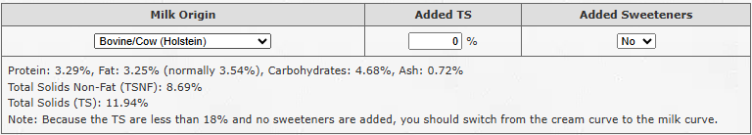

- Show Boiling Pressure: This function provides the user with the ability to determine the required minimum holding tube pressure when the operating temperature of the system is ≥89˚C. The only element effecting boiling pressure in the holding tube is temperature, so the only parameter that you need to input is the maximum normal “operating” temperature in the ‘Cut-out Temperature’ field of the calculator instead of the plant’s actual cut-out temperature. The calculator provides you with a “Min. Holding Tube Pressure”. See Appendix 7 for instructions.

- Show Known Volume: See Appendix 2 for information. This function is generally not utilized.
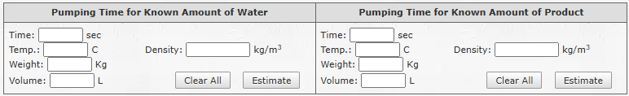

- Show Recorder Assessment: This function provides the user with the ability to determine whether sub-legal product is going forward following any divert flow caused by flow, temperature, or pressure. It is critical that you change the NSSC Lethality Holding Time Calculator from using the “Calculated (DHA-VS)” to “Calculated (NSRDEC)” from the drop-down. This will change the Vmax calculation from the forced 1.25 multiplier to the actual Vmax multiplier, whereby providing a more realistic measurement. See Appendix 6 for additional information.
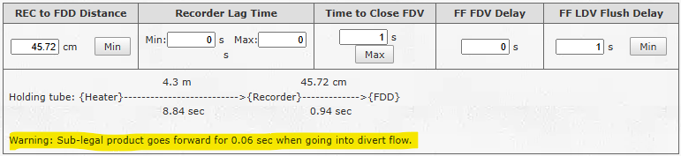

- Hide Rheological Assessment: Default is set to the required Show function. Do not change to Hide.

- Show Lethality Assessment: This function provides the user with the ability to determine Process and target lethality of the pasteurized product based on the parameters entered in the calculator.

- Graph: Default is set to the required Show function. Do not change to Hide.

- Hide Statement: Default is set to the required Show function. Do not change to Hide.

Step-by-step Use of the Calculator

Using the holding time calculator requires filling in all the input data fields, top-to-bottom and left-to-right. Each of the entries are described in detail in the following order.

- Holding Time is: Ensure this is set to the “Calculated (DHA-VS)” calculation mode (Official Approved Version).

- Product: Select appropriate product from the drop-down list.

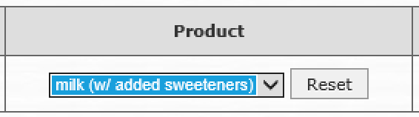

- Heat Exchange: Select indirect heat.

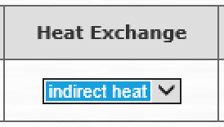

- Cut-Out Temperature: Enter the system cut-out temperature.

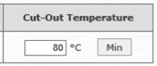

- Milk Fat Contents: Default is set to from the Product field. Change as needed. Note: See the notes under the “Product and Milk Fat” Entry sections on pages 9 and 10.

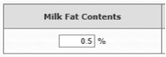

- Density: No change required unless the processor has actual density calculations of the product at the cut-out temperature or higher.

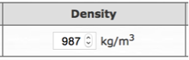
- Normally, density should not be changed as it is calculated automatically when the temperature or fat % change. Density should only be entered if it is measured at the cut-out temperature.

- Viscosity: No change required unless the processor has actual viscosity calculations of the product at the cut-out temperature or higher.

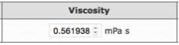

- Normally, viscosity should not be changed as it is calculated automatically when the temperature or fat % change. Viscosity should only be entered when it is measured at the cut-out temperature.

- Reynolds: Cannot be changed.

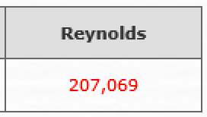

- Max Flow Rate: Enter the maximum possible product flow rate.

Note: For meter-based timing systems (MBTS) this will be the high-flow alarm set point.

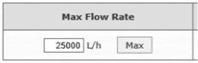

Note: Do not enter any commas or thousand separators.

- Holding Tube Length: Enter the verified holding tube length.

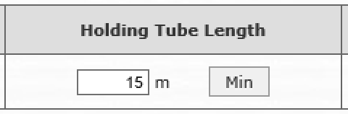

Note: It is critical to measure the length of the holding tube correctly and not rely on annotations found in engineering diagrams. All calculations depend on the accuracy of this value.

- Inner Diameter: Enter the verified inner diameter value.

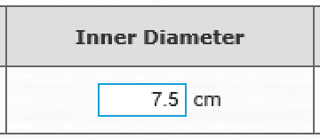

Note: It is critical to measure the inner diameter of the holding tube correctly and not rely on annotations found in engineering diagrams. All calculations depend on the accuracy of this value. If the (ID) is not known, you can measure the external diameter (OD) of the pipe. Once the OD is identified, open the NSSC Lethality Holding Time Calculator and enter in the appropriate ISO2037 / DIN 11850 OD and compare it to the generated ID.

- Volume: Cannot be altered.

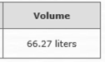

Note: This value is provided for informational purposes only. Useful when verifying that the calculator’s internal calculations are correct and / or comparing with plant calculations.

- Rheological Panel: Cannot be altered.

From left to right, the following sub-panels are shown: average flow, water turbulent flow, product turbulent flow, and product laminar flow. Sub-panels provide information about the prevalent type of flow, flow conversion factor, maximum product velocity, and holding time.

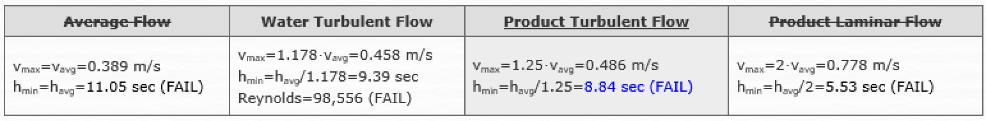

Average Flow is always crossed out to denote that it is not applicable. However, it is the basis for all other panels. The only exception is fluid egg product, on which time and temperature requirements are on an average basis instead of a turbulent or laminar basis.
Note: See page 12 for additional information.

Water Turbulent Flow shows what the holding time would be for water instead of the product selected in the product drop-down. Note: See Appendix 3, for instructions.

Product Turbulent Flow or Product Laminar Flow will be highlighted in gray to denote the prevalent product flow type based on the information entered. The panel will also indicate pass (in red to denote hot enough) or fail (in blue to denote not hot enough).

- Thermal Curve: Cannot be altered.

The thermal death curve provides the same information as the rheological panel in a graphical form. Here we can see whether the current holding time and temperature combination falls below the curve. The dot is shown in blue emphasizes that it is below the curve (not hot enough). Points below the curve do not meet the definition of pasteurization, ultra-pasteurization or commercial sterility lethality corresponding to each product curve.

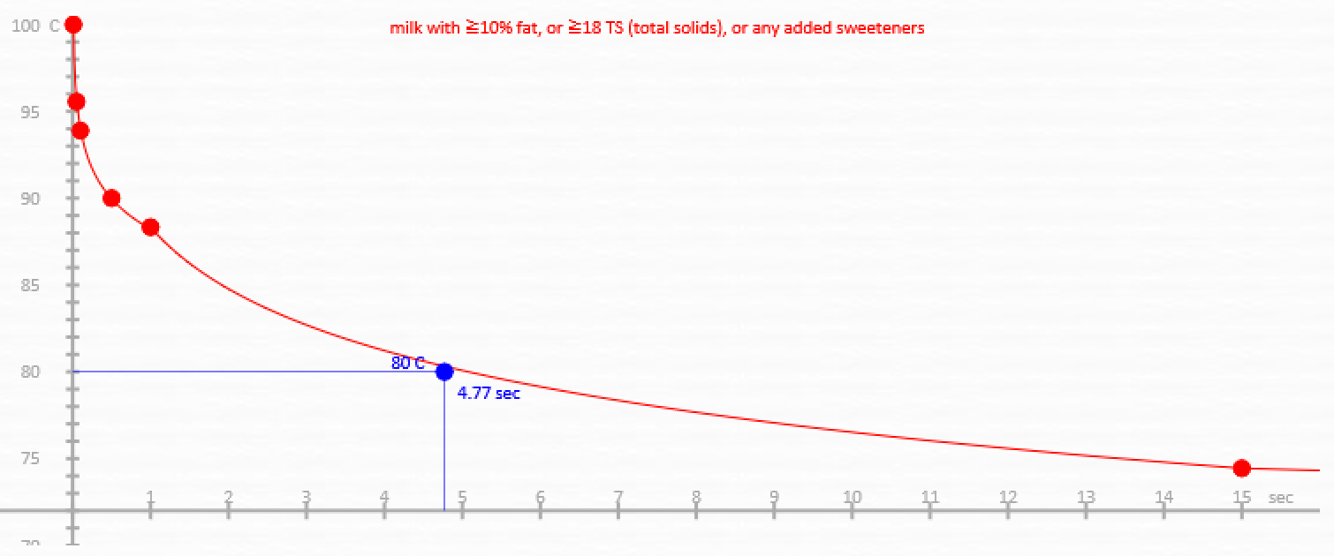

Values on, or above, the curve meet the corresponding definition or lethality associated with the product curves and are drawn in red to denote hot enough.

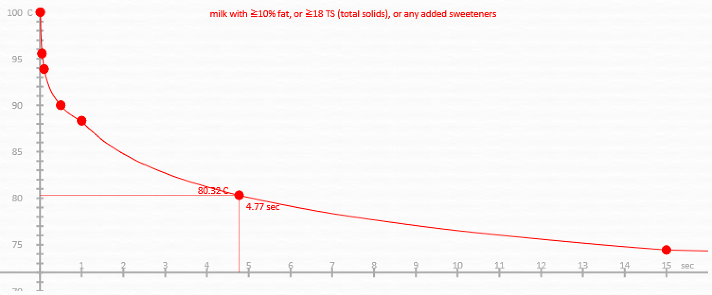

For UP products, purple is used to indicate public health is met and red is used to indicate commercial sterility is met.

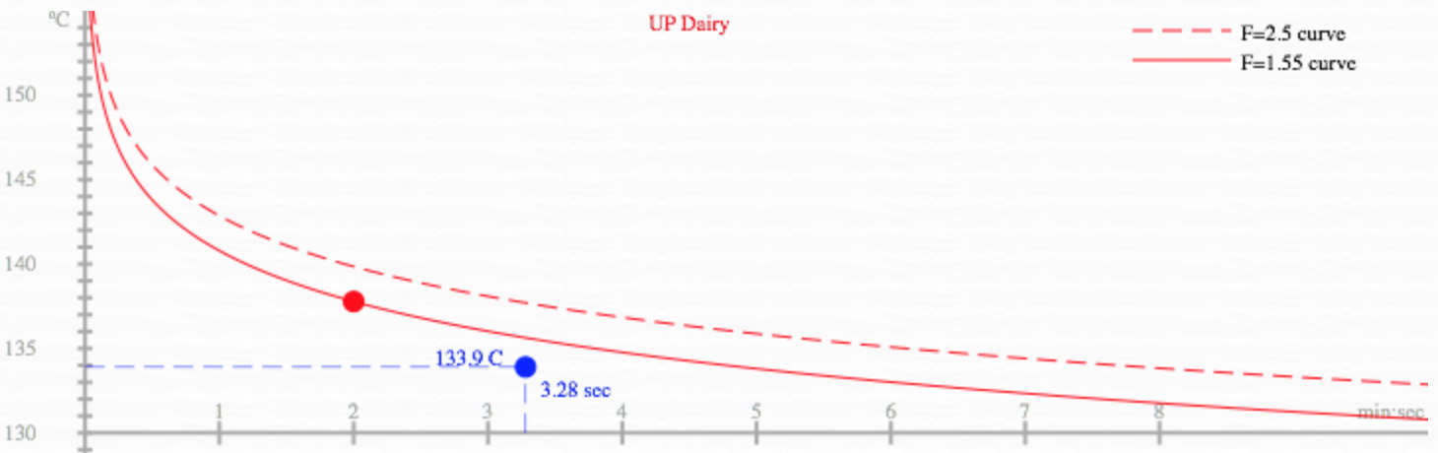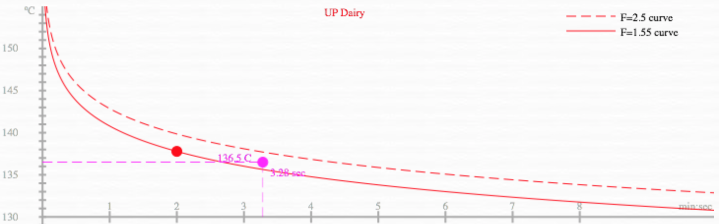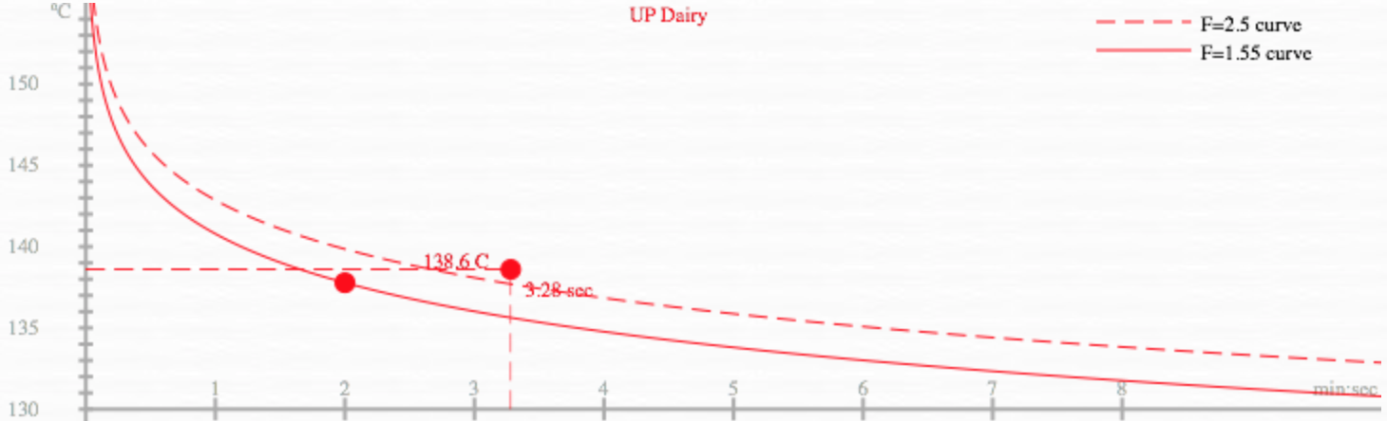

- US Forces Statement: Cannot be altered.

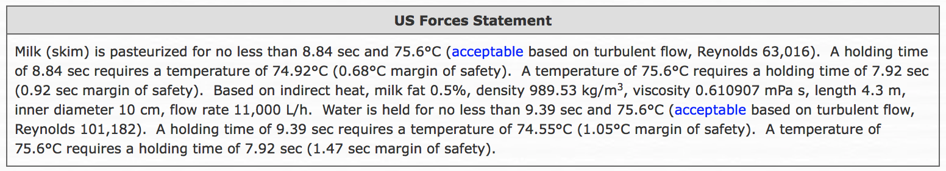

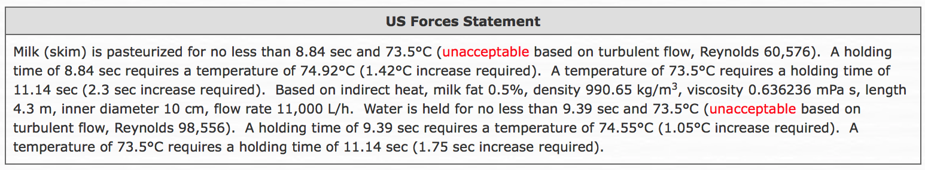

The US Forces Statement is a summary ready for copy-and-paste into a Veterinary Audit Report (VAR).

Safety of Holding Time Calculations
The safety of the calculator is based on two assumptions.
- Equivalent microbial destruction of time and temperature combinations.
- Proper determination of the holding time and cut-out temperature.

Pasteurization of Dairy Products: The following table presents the minimum time and temperature combinations required to meet the definition of pasteurization for dairy products in accordance with the PMO and the CFR.

Holding Time | Milk  (milk < 10% fat and no added sweeteners) | Cream  (milk ≧10% fat, or ≧ 18% TS (total solids), or any added sweeteners) | Ice Cream Mix  and Eggnog
30 min | 145°F or 62.78°C | 150°F or 65.56°C | 155°F or 68.33°C
25 sec | NA | NA | 175°F or 79.44°C
15 sec | 161°F or 71.67°C | 166°F or 74.44°C | 180°F or 82.22°C
1.0 sec | 191°F or 88.33°C
0.5 sec | 194°F or 90°C
0.1 sec | 201°F or 93.89°C
0.05 sec | 204°F or 95.56°C
0.01 sec | 212°F or 100°C

The dairy thermal curves in the calculator were validated by the FDA for DOD use and provide identical microbial destruction (for combinations listed above) or equivalent microbial destruction (for combinations not listed above). In both cases, the definition of pasteurization is met.

Proper determination of the holding time on pasteurizers not designed and / or operated in accordance with the PMO is not straightforward. The calculator uses a conservative approach that was also validated by the FDA for DOD use OCONUS, as presented in the next section (see Reference 2).

Pasteurization of Fluid Egg Products: The following table presents the minimum time and temperature combinations required to meet the definition of pasteurization for fluid egg products in accordance with the USDA and the CFR.
Note: 9 CFR 590.570 with regards to pasteurized fluid egg products, removed Table 1 in 2020 and now reads:
“Pasteurized egg products must be produced to be edible without additional preparation to achieve food safety and may receive additional preparation for palatability or aesthetic, epicurean, gastronomic, or culinary purposes”. See Reference 5.
The May 2026 publication of the “FSIS Food Safety Guideline for Egg Products” provides updated tables, specifically detailing time, and temperature requirements for eggs, white, plain deemed “not free from Salmonella Enteritidis” at various minimum pH ranges (worst case scenario) at the time of pasteurization (see Reference 6). Version 9.06 of the NSSC Lethality Calculator now provides users the ability to select these options from the Product, Data Input Panel of the calculator.

Product | 3.5 min | 6.2 min
Egg Whites Plain (SE negative only) | 134°F or 56.67°C | 132°F or 55.56°C
Whole Egg Plain | 140°F or 60°C Delete per reference 7 | 138°F or 58.89°C
Whole Egg Blends  (<2% added non-egg ingredients) | 142°F or 61.11°C | 140°F or 60°C
Sugar Whole Egg
(2-12% sugar added)
Plain Yolk
Fortified Whole Egg and Blends  (24-38% egg solids,  2-12% added non-egg ingredients) | 144°F or 62.22°C | 142°F or 61.11°C
Salted Whole Egg  (2% or more salt) | 146°F or 63.33°C | 144°F or 62.22°C
Salted Yolk
(2-12% salt added)
Sugared Yolk
(2% or more sugar added)
Egg Whites Plain  pH 7.8 (5.7-log) | See Reference 7.
Egg Whites Plain
pH 8.2 (5.7-log)
Egg Whites Plain
pH 8.8 (5.7-log)
Egg Whites Plain
pH 9.3 (5.7-log)

The fluid egg thermal curves in the calculator were validated by the USDA and adopted by the FREC for DOD use and provide identical microbial destruction (for combinations listed above) or equivalent microbial destruction (for combinations not listed above). In both cases, the definition of pasteurization is met.

Note: Proper determination of the holding time on pasteurizers not designed and / or operated in accordance with the USDA is not straightforward. The calculator uses a conservative approach validated by the FDA for dairy products, as presented in the next section.

Determination of Holding Time
Dairy Products are calculated using the following decision table to determine when to use either turbulent flow (flow conversion factor 1.25) or laminar flow (flow conversion factor 2.0).

PRODUCT | THERMAL CURVE | FLOW CONVERSION FACTOR
 |  | HHST  (holding ≦ 1 SEC) | HTST AND LTLT  (holding > 1 SEC)
Milk with < 10% milk fat  and < 18% TS  and No added sweeteners | milk curve | Always 2.0 (Laminar) | 1.25 if Reynolds > 10,000 (Turbulent)  2.0 if Reynolds ≦ 10,000 (Laminar)
Milk with ≧ 10% milk fat  or ≧ 18% TS  or Any added sweeteners | cream curve |  | Always 2.0 (Laminar)
Ice cream mix | mix curve
Eggnog

Additionally, when direct heat is used a 12% steam expansion factor is added (resulting in a 12% shorter holding time). This fixed direct heat expansion factor is provided for by the PMO.

HEAT EXCHANGE | EXAMPLES | STEAM EXPANSION FACTOR
indirect heat | heat exchange plates | 1.0
 | tubular heat exchanger
direct heat | steam injection | 1.12
 | steam infusion

Fluid Egg Products are always assumed to exhibit laminar flow, however, because minimum required holding times in the CFR were doubled by the USDA prior to the change to the CFR in 2020, a flow conversion factor of 1.0 is used instead of 2.0, in accordance with prior USDA holding time calculation instructions.
See the “Note” on page 22 under “Safety of Holding Time Calculations” Pasteurization of Fluid Egg Products with regards to pasteurized fluid egg products.

In general, FSIS considers a 5-log10 reduction of Salmonella to be safe in products that are edible without additional preparation to achieve food safety, including egg products. Using the former regulatory time and temperature pasteurization combinations, except for plain egg whites, provides a 5-log10 reduction. The historic regulatory pasteurization time and
temperature for liquid egg whites no longer achieves a 5-log10 reduction. Egg products plants could use the historic regulatory pasteurization time and temperature of 134°F (56.7°C) for 3.5 minutes as a safe harbor, provided that the eggs are not diverted from a farm that is Salmonella Enteritidis-positive. If plants are using the historic pasteurization time and temperature combination and receive multiple positive Salmonella results, then they will be required to reassess their hazard analysis and make appropriate corrective actions. Plants pasteurizing liquid egg whites that require a 5-log10 reduction of Salmonella should utilize one of the new egg white curves for products at pH 7.8, 8.2, 8.8, or 9.3. The lower (more neutral) the pH the harder it is to kill Salmonella. Select the curve that is lower or equal to the lowest egg whites processed by the plant."

PRODUCT | THERMAL CURVE | FLOW CONVERSION FACTOR
all fluid egg products | egg, whites plain (SE Negative Only) | 1.0
 | egg, whole, plain
 | egg, whole, blends (<2% added TS)
 | egg, whole, sugared (2-12% added TS)
 | egg, yolk, plain
 | egg, whole, blends (2-12% added TS)
 | egg, whole, salted (≧2% added TS)
 | egg, yolk, sugared (≧2% added TS)
 | egg, yolk, salted (2-12% added TS)
 | egg, whites, plain, pH 7.8 (5.7-log)
 | egg, whites, plain, pH 8.2 (5.7-log)
 | egg, whites, plain, pH 8.8 (5.7-log)
 | egg, whites, plain, pH 9.3 (5.7-log)

Ultra-pasteurized (UP) Products, dairy and all-other lethality is based on reaching minimum required target F₀ values for public health (minimum thermal process) and / or commercial sterility, as shown below (see Reference 8).

LETHALITY | PRODUCT | TARGET F₀
Commercial Sterility | Dairy | 2.5
 | All Others | 5.0
Minimal Thermal Process | Dairy | 1.55
 | All Others | 2.5

Appendix 1: Definitions
1. Pasteurization (PMO): The terms "pasteurization", "pasteurized" and similar terms shall mean the process of heating every particle of milk or milk product, in properly designed and operated equipment, to one (1) of the temperatures given in the following chart and held continuously at or above that temperature for at least the corresponding specified time:

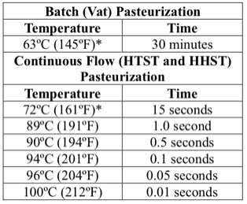
*If the fat content of the milk product is ten percent (10%) or greater, or a total solids of 18% or greater, or if it contains added sweeteners, the specified temperature shall be increased by 3ºC (5ºF).

Provided, that eggnog shall be heated to at least the following temperature and time specifications:
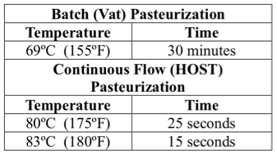

Provided further, that nothing shall be construed as barring any other process found equivalent to pasteurization for milk and milk products, which has been recognized by FDA as provided in section 403 (h)(3) of the FFD&CA.

2. Pasteurization (7 CFR 58.101) and (7 CFR 58.334): Pasteurization shall mean that every particle of product shall have been heated in properly operated equipment to one of the temperatures specified in the table and held continuously at or above that temperature for at least the specified time (or other time / temperature relationship equivalent thereto in microbial destruction) (see References 9 and 10).

7 CFR 58.101  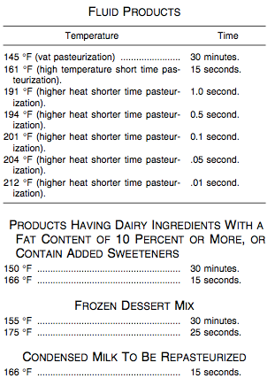 | 7 CFR 58.334  1. Cream for Butter Making:  165ºF/30 min or 73.89ºC/30 min  185ºF/15 sec or 85ºC/15 sec  or any other equivalent time temperature combination.  2. Cream for Plastic or Frozen Cream:  170ºF/30 min or 76.67ºC/30 min  190ºF/15 sec or 87.78ºC/15 sec  or any other equivalent time temperature combination.

Appendix 2: Maximum Flow Rate on Non-MBTS Based Systems
Magnetic Flow Meter (MFM) based systems have a regulatory MFM located after the timing pump and before the holding tube, and the high-flow alarm set point of the MFM is used as the worst-case scenario input in the calculator. However, there are cases where non-MFM control systems are in place, for example:
  - Systems that utilize positive displacement pumps in lieu of centrifugal pumps as their timing pump.
  - Current systems where the homogenizer, which is a positive displacement pump, acts as the timing pump. This occurs when there is no recirculation line from the outlet of the homogenizer to the inlet of the homogenizer (positive displacement).
  - There is a MFM in the system, but it is not properly located after the timing pump and before the holding tube.
  - There is a properly located MFM in the system, but it does not have a high-flow alarm that causes divert flow.

On non-MBTS based systems, the maximum flow rate should be determined in both forward flow and divert flow. In divert flow, the reduced back pressure will cause flow rate to increase. Since there is no MFM with a high-flow alarm to cause divert flow once a certain flow rate is exceeded, the holding time in divert flow could be significantly lower than in forward flow.

To calculate the maximum flow rate on a non-MBTS based system, the following procedure adapted from the PMO utilizing known volume may be utilized:
- Operate the system at or above the minimum legal pasteurization temperature, with all timing pumps at maximum capacity, using “product” (not water).
- Measure the amount of time that it takes to fill a known volume of product at the discharge outlet of the pasteurization system. The larger the vessel that is filled the more accurate the calculation will be. The average of a minimum of three measurements on a 38 liter or larger vessel should be utilized. Determine the average of the three measurements.
- Convert the average time to hours to obtain flow rate results in liters per hour.
time (h) = time (min) / 60 + time (sec) / 3600
- Calculate the product flow rate.
flow rate (product) = volume (L) / time (h)
- Perform the above procedure for both, forward and divert flow, and then use the higher of the two flow rate averages in the calculator.

Example calculation:
- Operating a heavy cream pasteurizer where the homogenizer is the timing pump at maximum capacity it takes 2 minutes and 16 seconds (average of three measurements in forward flow) to fill a vessel of a known 250-liter capacity with cream.
- Convert the time to hours to get flow rate results in liters per hour.
time (h) = time (min) / 60 + time (sec) / 3600 = 2 / 60 + 16 / 3600 = 0.038 hours
- Calculate the product flow rate by dividing the known volume by the time it took.
flow rate (product) = volume (L) / time (h) = 250 / 0.038 = 6,579 L/h

Appendix 3: Water Holding Time and Product Holding Time
Using water holding time as the product holding time will always result in an over-estimation of the actual product residence time, and this could potentially lead to under-processing and sub-legal product (raw product). The amount of over estimation depends on the product’s total solids (TS) content.

To understand this, it is useful to consider the following relations.

FACTOR | Water | Low-TS Product | High-TS Product
Density | ↑↑ | ↑ | ↓
Viscosity | ↓ | ↑ | ↑↑
Reynolds Number | ↑↑ | ↑ | ↓
Flow Conversion Factor | ↓ | ↑ | ↑↑
Holding Time | ↑↑ | ↑ | ↓

Products with high-TS include: manufacturer’s cream (40% milk fat), cultured dairy products, eggnog, ice cream mix, and fluid egg products.

Products with low-TS include: skim milk, 2% milk, and whole milk with no added total solids or sweeteners.

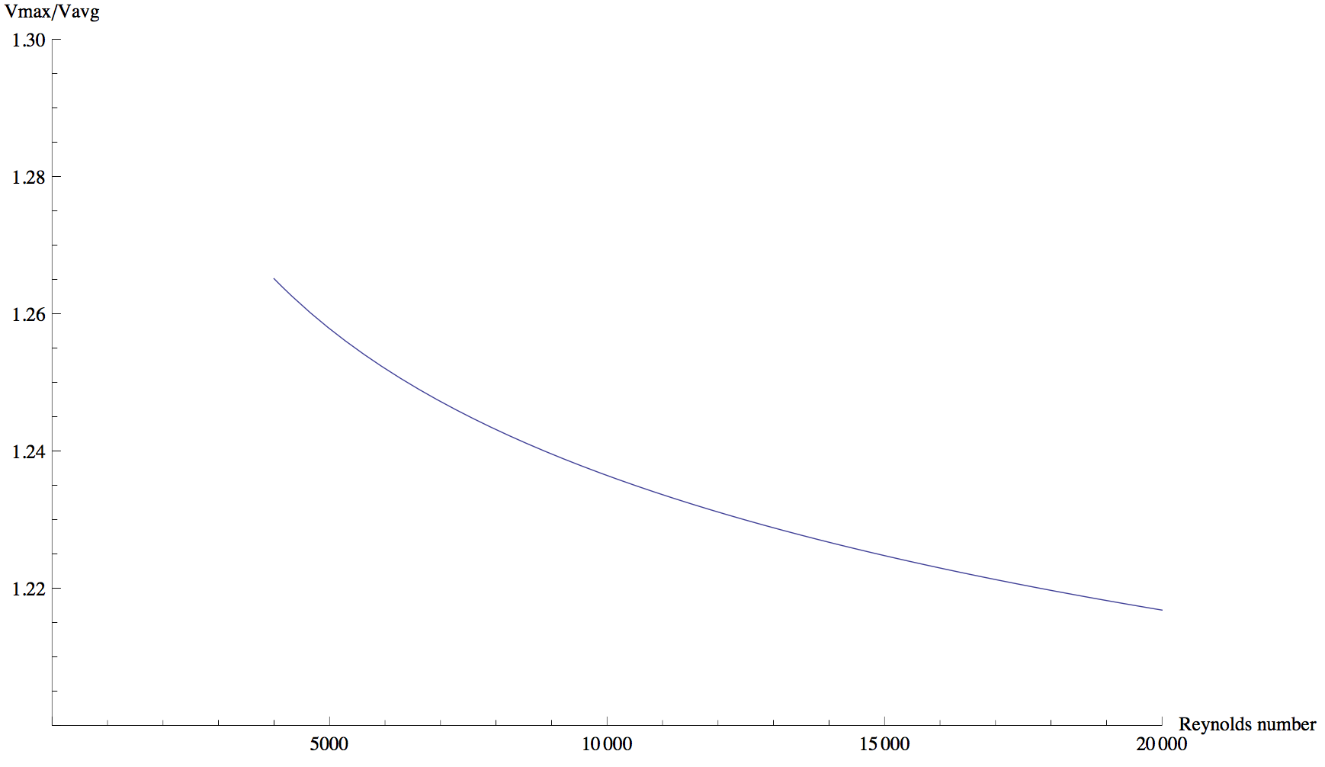

Another important consideration is that the turbulent flow conversion factor (Vmax / Vavg) is not a constant but, rather, varies with the Reynolds number as shown in the above plot. The higher the Reynolds number, the lower the flow conversion factor, with a minimum at 1. The FDA recommends adopting a flow conversion factor of 1.25 for all dairy products. This is a conservative approach, because 1.25 is higher (shorter holding time) than any possible value in the turbulent region (Reynolds > 10,000). However, the opposite is true for water, smaller flow conversion factors are more conservative / safer.

In summary, water is denser and less viscous than product. Therefore, the Reynolds number will be larger for water than product, as density is in the numerator and viscosity is in the denominator of the Reynolds number. Finally, the larger the Reynolds number the smaller the flow conversion factor and the longer the holding time for the fastest moving particle.
The following table describes expected values for a typical system.

 | Water | Low-TS Product | High-TS Product
Expected Values | Reynolds > 100,000  Turbulent Flow  Vmax/Vavg ~= 1.18 | Reynolds ~> 10,000  Turbulent  Vmax/Vavg ~=1.24 | Reynolds < 10,000  Laminar  Vmax/Vavg = 2.0
Conservative Values  (Recommended) | Reynolds > 200,000  Turbulent Flow  Vmax/Vavg ~= 1.15 | Reynolds ~> 10,000  Turbulent  Vmax/Vavg ~=1.25 | Reynolds < 10,000  Laminar  Vmax/Vavg = 2.0

With everything else (length, inner diameter, and flow rate) being equal, product will be held for less time than water. If there is no transition from turbulent (water) to laminar (product) the difference could be as low as 7%. However, if there is a transition from turbulent (water) to laminar (product), the difference could be as high as 42%.

A straightforward, but often impractical, solution is to determine water holding time and then consider product holding time as half of the measured water holding time.

Errors can creep up quickly when measuring water holding time (lower flow rate than expected, timer start or stop errors, etc.) and also when calculating water or product holding time (incorrect dimensions or flow rate). For this reason, it is highly desirable to both calculate and measure water holding time to rule out any hidden measurement and / or calculation errors. To that end, the following procedure is proposed as a best practice to verify product holding time.

Procedure to verify measured holding time using water:
  - Measure system holding time using water and a conductivity test. The PMO recommends using the average of six (6) consecutive measurements within 0.5 seconds of each other.
  - Use the calculator’s default Official setting “Calculated (DHA-VS)”, the appropriate product normally produced in the system, direct / indirect heat mode, cut-out temperature, product fat% (or density and viscosity if they have been determined at or above cut-out temperature), maximum possible system flow rate, and holding tube length and diameter.
  - Compare the holding time shown in the “Water Turbulent Flow” panel with the previously measured average holding time with water.
  - If the two values do not agree, within a small margin of error, procedures should be questioned. Either the holding time measurement or the holding time calculation is wrong.
  - If the two values agree, the panel that is not crossed out in the calculator, either product turbulent or laminar flow, provides the actual holding time, which will always be shorter than the water holding time. The thermal death curve and US Forces Statement provide further guidance on product holding time.

Note: Because product holding time is always shorter than water holding time, it is possible to have a pasteurizer that passes with water but fails with product. Regardless of whether products contain high or low TS, the above procedure should always be utilized to verify and convert water holding time to product holding time and avoid under processing products by violating the definition of pasteurization.

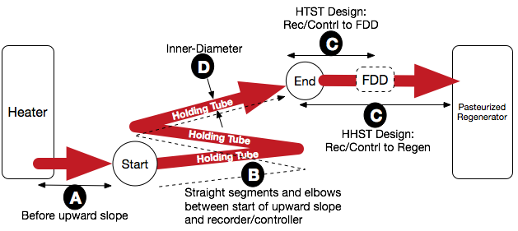
Appendix 4: Measurement of the Holding Tube
At a minimum, the following information should be documented.

Measurement | Value | Units | Description
A |  | meters | Distance from the outlet of the heater to the beginning of the holding tube.
B |  | meters | Distance from the beginning of the holding tube to the thermal recorder / controller (end of holding tube).
B1 |  | - | Number of straight-line sections.
B2 |  | meters | List of all straight-line sections’ length.
B3 |  | - | Number of elbows.
B4 |  | meters | List of all elbow lengths.
C |  | cm | Distance from the thermal recorder / controller to the flow diversion device (HTST) or regenerator (HHST).
C1 |  | cm | Distance from the SIP to flow diversion device (HTST).
D |  | cm | Inner diameter of the holding tube.

Establishment: ________________________________________________________________________________
Pasteurizer identification: ________________________________________ Date: __________________________
Verified By (Company Name/Phone): ______________________________________________________________
Verified By (Person Name/Signature): ______________________________________________________________
A = Indicate the distance from the outlet of the heater to the beginning of the holding tube. The beginning of the holding tube may be a separate salt injection port (SIP) or a currently installed temperature transmitter (TT) that is removed and the salt injection probe is added during testing.

B = Indicate the distance from the beginning of the holding tube to the thermal recorder / controller (end of holding tube). The beginning of the holding tube may be a separate SIP or a currently installed temperature transmitter (TT) that is removed and the salt injection probe is added during testing. The end of the holding tube may be a separate SIP or the thermal recorder / controller, which is removed, and the SIP and the salt injection probe are added during testing.

B1 = Indicate the total number of distinct straight line pipe sections.

B2 = Indicate the length of each distinct straight pipe section.

B3 = Indicate the number of distinct elbows.

B4 = Indicate the length of each distinct elbow. Measure all elbow bends by the inner diameter, as illustrated with the green line in the figure below. In the case that the holding tube is covered, measure the bends by the best possible practice.

C = Indicate the distance from the thermal recorder / controller to the flow diversion device (HTST) or pasteurized regenerator (HHST).

C1 = Indicate the distance from the SIP to flow diversion device (HTST) only when there is a separately installed SIP that is used for holding time testing.

D = Indicate the inner diameter of the holding tube. For each separate and distinct inner diameter in the holding tube (between SIPs), indicate each inner diameter. Also indicate which straight line pipe sections and elbows utilize which inner diameter.

Appendix 5: Calculating Holding Time with Multiple Pipe Diameters

So long as the following conditions are met, the minimum holding time can be easily calculated:
- There is no way to shorten the holding tube, such as valves or connections between the exit of the heater and the recorder / controller located at the end of the holding tube.
- The various inner diameters remain equal / constant for the entire length of each sub-section.
- The various inner diameter values are known, and verifiable, for all sub-sections.
- The length of each sub-section is known and verifiable.
- If these conditions have been met, then perform the following:
  - Perform calculations in Steps 1.1 and 1.2 below for determining Product holding time of holding tubes with multiple pipe diameters to determine if the plant’s product holding time is acceptable.
  - Perform calculations in Steps 2.1 and 2.2 below for determining Water holding time of holding tubes with multiple pipe diameters to determine if the plant’s water holding time is acceptable, and comparable to measured holding time with water.

Step 1.1 (Product): When there are two sub-sections, one very short and one very long:
Calculate holding time using the longer holding tube section only and disregard the shorter sub-section completely. If the holding time passes utilizing only the measurements of the longest section of the holding tube, no further calculation is required. Utilize this US Forces Statement from the calculator (for Product) when reporting in the Pasteurizer Checklist and VAR.
- If the product holding time has a margin of safety of less than 1.0 sec, then also perform Step 1.2.
- If the longer section does not meet the minimum required holding time per the NSSC calculator, then perform Step 1.2.

Step 1.2 (Product): This step is applicable for the following three situations:

- When the longer section does not meet the minimum required holding time per the NSSC calculator in Step 1.1.
- When the product holding time in Step 1.1. has a margin of safety of less than 1.0 sec.
- When the sub-sections are of somewhat similar length.

    - Perform the calculation for all the adjacent sub-sections of inner diameter separately and document the time. To determine the overall product holding time, add this holding time and the holding time obtained in Step 1.1. The result is the “overall” product holding time. Keep in mind that the different sub-sections may have different types of flow (laminar or turbulent) for each section being calculated.
    - Determine if the overall Product holding time is acceptable:
- At this point make sure the correct cut-off temperature is entered and remains in the cut-off temperature field. All other values such as the length and diameter for the last segment are irrelevant and may be left as-is.” or similar.
- In the first dropdown (top-left) select “Measured (FDA)”.
Note: Selecting “Measured (FDA)” transforms the calculator into an entirely different mode of operation that is designed to evaluate given or known holding times against cut-out temperatures. The “Measured (FDA)” calculation assumes the worst-case scenario by accepting known empirical measurements instead of calculating holding time and therefore results are provided in “laminar flow” dependent of whether actual calculated flow is “Turbulent”.
- In the “Measured Holding Time” section, enter the “overall” product holding time determined in Step 1.2a above.
- Determine if the “overall” product holding time is acceptable. If the holding time passes under “Measured Holding Time”, no further action is required. The US Forces Statement from the “Measured (FDA)” calculation should be used as the appropriate statement when determining overall product holding time of holding tubes with multiple pipe diameters. Utilize this US Forces Statement from the calculator (for Product) when reporting in the Pasteurizer Checklist and VAR.
Note: The US Forces Statement will only default to “Water is pasteurized…”, therefore, when pasting the statement for Product, replace the word “Water” with “Product”.

Step 2.1 (Water): When there are two sub-sections, one very short and one very long:
Calculate holding time using the longer holding tube section only and disregard the shorter sub-section completely. If the holding time passes utilizing only the measurements of the longest section of the holding tube, no further calculation is required. Utilize this US Forces Statement from the calculator (for Water) when reporting in the Pasteurizer Checklist and VAR.
- If the water holding time has a margin of safety of less than 1.0 sec, then also perform Step 2.2.
- If the longer section does not meet the minimum required holding time per the NSSC calculator, then perform Step 2.2.

Step 2.2 (Water): This step is applicable for the following three situations:

- When the longer section does not meet the minimum required holding time per the NSSC calculator in Step 2.1.
- When the water holding time in Step 2.1. has a margin of safety of less than 1.0 sec.
- When the sub-sections are of somewhat similar length.

- Perform the calculation for all the adjacent sub-sections of inner diameter separately and document the time. To determine the overall water holding time, add this holding time and the holding time obtained in Step 2.1. The result is the “overall” water holding time.
- Determine if the overall Water holding time is acceptable:
- At this point make sure the correct cut-off temperature is entered and remains in the cut-off temperature field. All other values such as the length and diameter for the last segment are irrelevant and may be left as-is.” or similar.
- In the first dropdown (top-left) select “Measured (FDA)”.
Note: Selecting “Measured (FDA)” transforms the calculator into an entirely different mode of operation that is designed to evaluate given or known holding times against cut-out temperatures. The “Measured (FDA)” calculation assumes the worst-case scenario by accepting known empirical measurements instead of calculating holding time and therefore results are provided in “laminar flow” dependent of whether actual calculated flow is “Turbulent”.
- In the “Measured Holding Time” section, enter the “overall” water holding time determined in Step 2.2a above.
- Determine if the “overall” water holding time is acceptable. If the holding time passes under “Measured Holding Time”, no further action is required. The “Measured (FDA)” calculation should be used as the appropriate statement when verifying overall water holding time of holding tubes with multiple pipe diameters and should be used when reporting in the Pasteurizer Checklist and VAR.
Note: If utilizing the US Forces Statement for “Water”, replace the word “pasteurized” with “held” and delete the last sentence that reads: Based on the milk (18% TS) curve.

Appendix 6: Location of the Recorder / Controller in HTST Systems
The PMO prohibits locating the Recorder / Controller (R/C) more than 45.72 cm (18 inches) upstream from the flow diversion device to prevent raw product from going forward at high flow rates. This stringent requirement, however, does not consider several parameters that would potentially allow raw product to go forward when either activating forward flow (FF) or divert flow (DF). For this reason, we can utilize the “Show Recorder Assessment” from the “View” drop-down menu within the NSSC Lethality Holding Time Calculator to determine whether the current R/C location is acceptable based on the current maximum flow in the system. The following steps cover the necessary actions that the auditor must use to determine acceptability or alternate means of compliance:

Step | Action / Issue | Description / Solution
1 | Complete the required fields in the calculator. | Product, Heat Exchange, Cut-Out Temperature, Milk Fat Contents, Max Flow Rate, Holding Tube Length, and Inner Diameter.
1a | Holding Time is | Change the NSSC Lethality Holding Time Calculator from using the “Calculated (DHA-VS)” to “Calculated (NSRDEC)” in the ‘Holding Time is’ drop-down.
2 | Click on the “View” tab and select the “Show Recorder Assessment” tab. Complete the following fields:  - REC to FDD Distance  - Recorder Lag Time (Min) and Max)  - Time to Close FDD  - FF FDD Delay  - FF LDV Flush Delay | 1. REC to FDD Distance: Enter the actual distance between the recording / controlling (R/C) thermometer and the Flow Diversion Device (FDD), as measured.  2. Recorder Lag Time (Min): Always enter 0 sec, which is the worst-case scenario when going from divert flow to forward flow (no lag).  3. Recorder Lag Time (Max): Enter the sum of the thermometric response for the R/C and the signaling time between the R/C and divert valve from the plant.  4. Time to Close FDD: Modern valves will meet the PMO requirement of NMT 1 sec time to close the Flow Divert Valve (FDV) when going from forward flow to divert flow.  5. FF FDD Delay: This is the time it takes the FDD to open when in divert flow. The worst case of 0 sec should be used as partially opening the valve will result in product flowing forward.  6. FF LDV Flush Delay: In single stem flow diversion devices, enter 0 sec. On dual stem FDDs, enter the programmed Leak Detect Valve (LDV) yoke flush delay. This is the delay from when the FDD activates forward flow and when the LDV activates forward flow. The PMO requires NLT 1 sec yoke flush, but the actual delay should be recorded. If the FDD is a single stem design, this must be changed to zero ‘0’.
3 | Once all the Fields are entered, determine if a warning appears. If so, see 3a – 3d below. | See 3a with regards to a warning when going into divert flow.  See 3b – 3c with regards to a warning when going into forward flow.
3a | Example warning: Sub-legal product goes forward for 0.04 sec when going into divert flow. | Options when either a single-stem or dual-stem FDD.  With this warning, one solution is to meet the minimum required ‘REC to FDD Distance’. Click on the “Min” tab in the ‘REC to FDD Distance’ field. Distance given will be the optimum R/C location that will prevent sub-legal product from going forward when switching to either DF or FF. When clicked, the ‘Holding Tube Length’ will automatically change to the new length taking into consideration the R/C is being moved upstream from the FDD. With this option, the plant must be made aware of the fact that at any time the maximum flow rate of the system increases, there is a good possibility that the R/C will have to be moved also. If this is not a feasible option, see the alternate design protocol in ‘4’ below
3b | Example warning: Sub-legal product goes forward for 0.39 sec when going into forward flow (unless there is a forward flow delay timer). | Options when a dual-stem FDD.  With this warning, the solution would be one of the following: 1) increase the ‘FF LDV Flush Delay’; 2) add a ‘FF FDD Delay’.
3c | Example warning: Sub-legal product goes forward for 0.39 sec when going into forward flow (unless there is a forward flow delay timer). | Options when a single-stem FDD.  With this warning, the solution would be to add a ‘FF FDD Delay’.
4 | Continued the next page.
4 | In those instances where it is not possible or feasible for the plant to move the R/C to a location as indicated in 3 above, these alternate design protocols may be an acceptable option for the plant. | 1. Alternate design protocols:  a. Install TT1 or utilize TT1 currently in place at the beginning of the holding tube.  b. The currently installed TT2 (temperature recorder / controller located near FDD1) and TT3 (temperature indicator / official thermometer) remain in place. Note: TT2 no longer has the legal requirement for distance to FDD1 based on the utilization of TT1.  c. System logic is added to TT1 that ensures the system activates divert flow at the cut-out temperature. Activating cut-out at TT1 will allow the FDD1 to fully close before sub-legal product travels from TT1 to FDD1. TT1 now becomes the legal requirement for distance to FDD1.  d. The only physical modification is the addition of system logic to TT1 (i.e., forward flow delay).  e. The official length of the holding tube, TT1 to TT2 is not affected and TT2 remains in place as the official end of the holding tube.  Note: One additional TT is required at TT1 and TT2 for daily comparison requirements. These additional TTS require quarterly calibration.  ********************************************************************************************  HEATER-> TT1 -----------> TT2 -> FDD1 -> REGEN-> COOLER-> TT3 -> FDD2  ********************************************************************************************  2. Given the minimum required pasteurization temperature, the following sequence logic options are required:  a. While in forward flow, if temperature drops at TT1 to the cut-out temperature, FDD1 SHALL divert.  b. While in forward flow, if cut-out occurs at TT2, FDD2 SHALL activate divert flow, followed by CIP.  To minimize the potential for the system activating divert flow at TT2, cut-out temperature at TT1 should consider the temperature loss across the holding tube (between TT1 and TT2) and increase the cut-out temperature at TT1 accordingly. Calibration error allowance at TT1 must also be considered when determining the appropriate cut-out temperature. TT1 and TT2 now require quarterly calibration.  If CIP is not a viable option, the plant can opt for one of the two alternatives (1) or (2) below:  (1) While in forward flow, if cut-out occurs at TT2, FDD2 SHALL activate divert flow and the cooler will be turned off to allow the system to be heated up to pasteurization temperature (TT3) all the way to FDD2. Once heated up to FDD2 and the cooler once again reaches the plants required product temperature, and TT2 is greater than the cut-out temperature (plus any required system delays), forward flow can be initiated at FDD2.  (2) While in forward flow, if cut-out occurs at TT2, FDD2 SHALL NOT activate divert flow, however the system must alarm and the plant must perform phosphatase testing on each batch of pasteurized product. If testing occurs prior to filling and a positive phosphatase test occurs, the plant will take actions to discard this product for sale to U.S. Forces. If testing is performed on finished product instead, and a positive phosphatase test occurs, the plant will take actions to recall the product.  3. If the plant has a separate salt injection port (SIP) installed that is used during holding time testing instead of the TT2 location, or the plant can add a separate SIP to be used in lieu of the TT2 location, then the following options are available:  (1) Move TT2 to the location as determined by the NSSC Lethality Holding Time Calculator as long it does not exceed the location of the currently installed SIP and there is enough pipe to accommodate the move.  (2) Add pipe between FDD1 and the SIP to facilitate 3(1) above.  (3) Add a separate SIP port upstream from the correctly placed TT2 if the shortened holding tube length will meet the minimum required holding time.

Appendix 7: Holding Tube Pressure Requirements when utilizing Indirect Heating with a Normal Operating Temperature of ≥89˚C
The one critical pressure consideration for systems utilizing indirect heating when the operating temperature ≥89˚C is that the holding tube pressure in UP / UHT / HTST / HHST Systems Operating Near or Above Boiling Point must be 10 psi (0.69 bar) higher than boiling pressure of water at the operating holding tube temperature.

Note: The PMO requires only a cut-out temperature of ≥89˚C; however, for U.S. Forces requirements, we require this at the normal operating temperature.

The requirement in the PMO is when the holding tube pressure drops below the boiling pressure +10 psi (+0.69 bar), the flow diversion device (FDD) should divert. This is to account for the possibility of vaporization within the holding tube which could substantially reduce residence / holding times and / or provide uneven residence time within the holding tube.

To determine the required minimum holding tube pressure, use the NSSC Lethality Holding Time Calculator and mouse-over “View” at the top of the calculator and select “Show Boiling Pressure”. The only element effecting boiling pressure in the holding tube is temperature, so the only parameter that you need to input is the maximum normal “operating” temperature in the ‘Cut-out Temperature’ field of the calculator instead of the plant’s actual cut-out temperature. The calculator will provide you with the required “Min. Holding Tube Pressure”.

To measure the operating holding tube pressure, a pressure transmitter or pressure indicator before or after the holding tube should be available in the system to provide actual holding tube pressure during production. If the operating holding tube pressure is always greater than the minimum required holding tube pressure obtained from the NSSC Lethality Holding Time Calculator, then the requirement for having the system logic wired to cause divert flow is not required. However, if the pressure in the holding tube drops below the minimum required pressure, then the pressure transmitter must be a part of the system’s computer logic and cause divert flow.

Technical Points of Contact for the Holding Time Calculator
The points of contact for technical questions about the holding time calculator are:
- Mr. Kenneth E. Robinson at ken.robinson@ymail.com
- Mr. Vicente Silvestre at vsilves@gmail.com.

References
- MIL-STD-3006, Sanitation Requirements for Food Establishments, current edition.
- DHA VS Technical Guidance MIL STD 3006C: Alternate Methods for Determining Time Temperature Requirements in OCONUS Dairy Plants, 28 July 2015
- DHA VS, MEMORANDUM FOR CHIEF, VETERINARY SERVICES BRANCH, Minutes of the Food Risk Evaluation Committee (FREC) Meeting, 21-22 April 2016, Dated May 12, 2016.
- Grade A Pasteurized Milk Ordinance (PMO), current Revision, U.S. Department of Health and Human Services, Public Health Service, Food and Drug Administration.
- Pasteurization of Liquid Eggs (9 CFR 590.570).
- FSIS Food Safety Guideline for Egg Products, dated May 2026. See Appendix III, Table III.A. for egg, whites (plain).
https://www.usda.gov/sites/default/files/guidance-documents/FSIS.%20FSIS%20Food%20Safety%20Guideline%20for%20Egg%20Products.pdf
- USDA Time and Temperatures for Plain Egg White at various pH’s.
- DHA VS, MEMORANDUM FOR CHIEF, VETERINARY SERVICE BRANCH, Minutes of the Food Risk Evaluation Committee (FREC) Meeting, 12-14 September 2017, Dated October 2, 2017.
- Pasteurization (Pasteurized) Definitions [7 CFR 58.101(n)].
- Pasteurization [7 CFR 58.334 (a) and (b)].

